Company Database Schema

- Display the Department id, name and its manager id and the name of its manager.
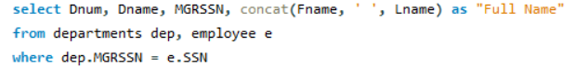
- Display the departments’ name and the project name of the under their control.
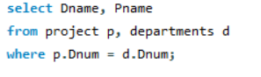

- Display the dependent name for all the dependence and the name of the employee they depend on him/her.
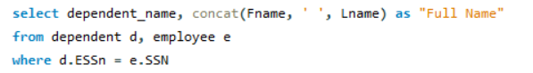
- Retrieve the fname, pname of all employees work in department 10 who works more than or equal 10 hours per week on ‘AL Rabwah’ project.
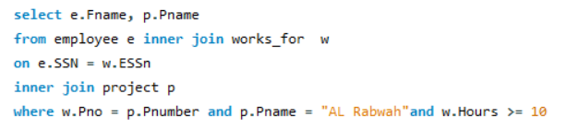
- Find the fname of the employees who directly supervised with ‘Kamel Mohamed’.
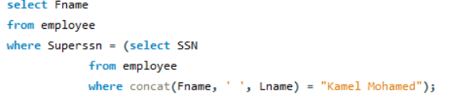
- List the last name of all managers who have no dependents.
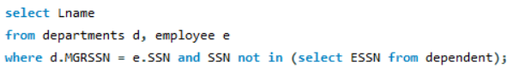
- Display the department name which has the smallest employee ID over all employees' ID.
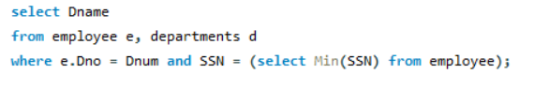
- For each department, retrieve the department name and the maximum, minimum and average salary of its employees.
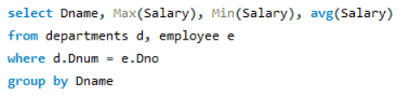
- For each department >>> display department number, department name and number of its employees
-- if its average salary is less than 1200
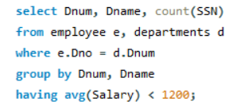
- Retrieve a list of employees (fname) and the projects (project name) they are working on ordered by department no, last name, first name.
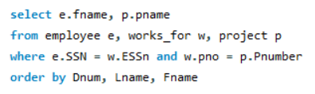
- Find the project number, the controlling department name, the department manager last name, address and birthdate. For each project located in ‘Cairo’ City
